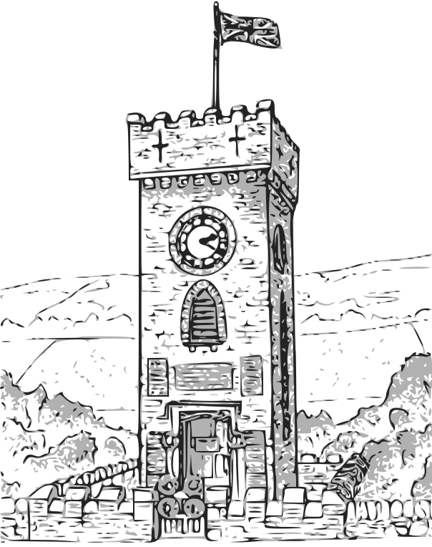
Stocksbridge Town Council

GRANT APPLICATION FORM

1. | Name of group:
2. | Contact details of Chair |  |  |  |  |  |  | Contact details of Secretary
 | Name: |  |  |  |  |  |  | Name:
 | Address: |  |  |  |  |  |  | Address:
 | Tel: |  |  |  |  |  |  | Tel:
 | Mob: |  |  |  |  |  |  | Mob:
 | Email: |  |  |  |  |  |  | Email:
3. | Amount of funding requested:
4. | Would the project continue or not continue without this grant?
5. | Geographical area covered by activity/project:
6. | Please state membership numbers of the group and state what percentage live in the area
 | (i.e. Stocksbridge, Deepcar and Bolsterstone):
7. | Who are the intended users of the activity/project/who will it benefit?

8. | Reason(s) for request:
 | (Continue on separate sheet(s) if necessary)
9. | Breakdown of costs for the funding required:
 | (Continue on separate sheet(s) if necessary)

10. | Please supply a copy of the following (if applicable):
- Public liability insurance schedule/policy and renewal receipt stating current
cover to a minimum of £2million in any one accident
 | - Your latest set of financial accounts, a note of the current balance in hand and what this is earmarked for (if anything)
 | - A copy of your group’s constitution (unless previously supplied)
 | - Copy of any permission required for 3rd party use
11. | If relevant, is there a policy in place for safeguarding/child protection? |  |  |  |  |  |  |  |  | YES / NO
12. | Please give details of any other sources of grants which you have approached and
 | the results of these requests:
 | 1) |  |  |  | £ |  |  | Successful |  | YES / NO
 | 2) |  |  |  | £ |  |  | Successful |  | YES / NO
 | 3) |  |  |  | £ |  |  | Successful |  | YES / NO
13. | Please confirm that you will give Stocksbridge Town Council credit for the grant in all
 | media or other publicity (such as programmes/leaflets, newspapers, social media, web
 | pages, sponsored clothing etc.): |  | YES / NO
I enclose all the required details.
I certify that the above information is correct to the best of my knowledge.
If the grant application is successful, I agree to abide by the Council’s Grants Policy in full.
Signed: |  |  |  | (Chair) |  |  | Date:
Signed: |  |  |  | (Position in group) |  |  | Date:
Please return to Stocksbridge Town Council, Town Hall, The ARC, Manchester Road,
Stocksbridge, Sheffield, S36 2DT
Telephone: 0114 2887895
Email: admin@stocksbridgetowncouncil.gov.uk
For Council Use Only:-
Application Received (DD/MM): |  | Grant Allocated: | £
Application to Finance Committee (DD/MM):
Approved / Declined (circle) | See Minutes | Grant Returned Unused: | £
Cheque Number: |  | Total Cost of Grant: | £
Account: |  | Total Cost of Grant: | £

Please refer to the Town Council’s website which has a dedicated page for GDPR this holds information on
how your data is handled by the Town Council: www.stocksbridgetowncouncil.gov.uk

